Day 41 Spark Introduction & Architecture

RDD – Resilient Distributed Dataset
Google Map Reduce
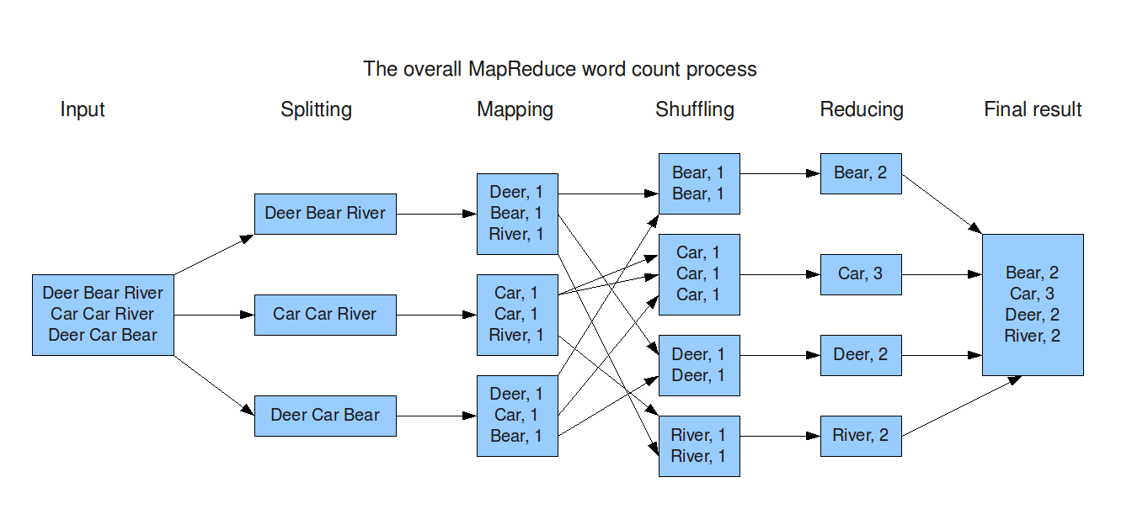
Google File System

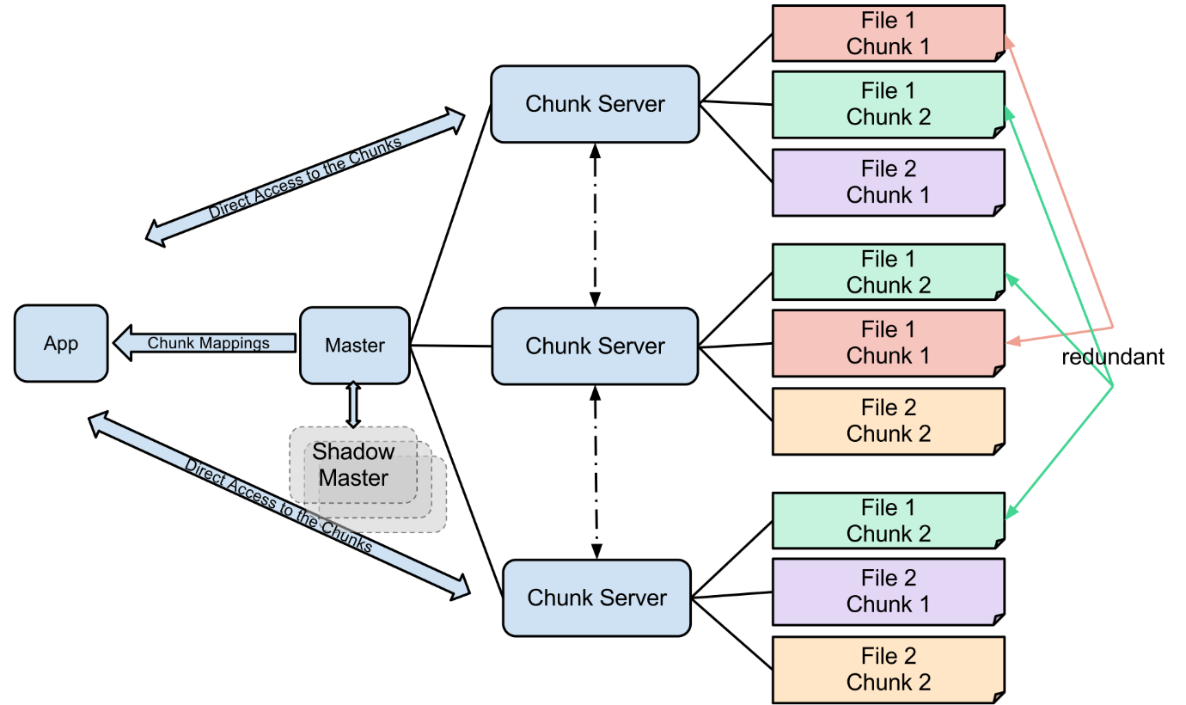

Spark SQL
Big Data – Operation
HDFS – Hadoop Distributed File System ( Cluster -Group of devices)
Hadoop relies on Disk Storage (Hard Disk) – (Read /Write Speed will be low)
Spark is Distributed Data Processing Engine. (In-Memory – RAM & Caches) 10-100X times faster than Hadoop.
Spark has many modules.
- Spark Core – RDD (Resilient Distributed Dataset), DAG (Directed Acyclic Graph)
- Spark SQL ( Data frames – by using SQL )
- Spark ML (Machine Learning )
- Spark Streaming (Real time Data Analysis, Stream processing)
- GraphX
Installing Spark in Windows 11.

https://spark.apache.org/downloads.html -- Download URL
Spark is written using Scala. But it easily integrates with Java, Python, R, SQL & Scala also.

PySpark – Python flavor

Env Variables
SPARK_HOME = C:\spark-3.5.7-bin-hadoop3
HADOOP_HOME = C:\hadoop

Add these env variables to the PATH. (%SPARK_HOME%\bin;%HADOOP_HOME%\bin)

Running in Docker

Simple Maven based Java Project with Spark Dependencies.

ETL – Extract Transform & Load. (CSV file to DB) --- Using Core JAVA only. (We created stand-alone application using Maven)

Spark Architecture. – Master/Slave Architecture.

- Driver Program (Boss) – Coordinates entire Spark application. [Spark Session/Context] – RDD, Data Frames, Transformations/actions
- Cluster Manager – Helps to allocate resources across cluster (CPU, Memory) Standalone, YARN, Mesos & K8s.
- Executor (Worker Nodes) – Perform the actual computation on worker nodes.

Job Execution Flow
- User Code Creation (Spark API – Pyspark, scala, Java, R)
- Driver creates DAG
- Job Submission
- Cluster Manager allocates resources to the Executors.
- Each executors runs the task in parallel.
- Result Collection (Reducing/Actions/Transformations)

In-memory Processing (Faster than MapReduce)
Fault Tolerance - Automatically recovers lost computations.
Lazy Evaluation – Optimizes execution before running.
Scalability – Runs on single machine as well as on a cluster.
Unified Engine – Supports batch processing, streaming, SQL, ML & Graph

ETL – Extract data from Data Source, Transformation & Loading (SQL/No-SQL, Visualization)

Spark SQL - using SQL. DataFrames using Spark.

POM.xml file is the backbone of Maven Project.
Pom.xml contains two important metadata. groupId, artifactId, version(optional)
groupId – reverse of company url (all lower case) [com.example]
artifactId – name of the project (all lower case) [sparksqldemo]
base package – groupId.artifactId (com.example.sparksqldemo)

